**Supervised Learning and Unsupervised Learning**

**Supervised Learning**

In supervised learning, the training data provided to the machines work as the supervisor that teaches the machines to predict the output correctly. It applies the same concept as a student learns in the supervision of the teacher.

The aim of a supervised learning algorithm is to**find a mapping function to map the input variable(x) with the output variable(y).**

supervised learning can be used for **Risk Assessment, Image classification, Fraud Detection, spam filtering, etc.**

**How Supervised Learning Works?**

In supervised learning, models are trained using labelled dataset, where the model learns about each type of data.

Once the training process is completed, the model is tested on the basis of test data (a subset of the training set), and then it predicts the output.

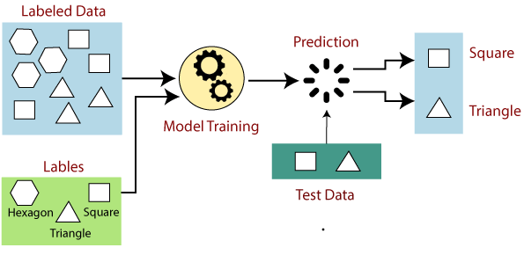

**Types of supervised Machine learning Algorithms:**

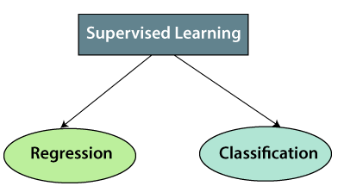

1. **Regression:**

Regression algorithms are used if there is a relationship between the input variable and the output variable. It is used for the prediction of continuous variables, such as Weather forecasting, Market Trends, etc. Below are some popular Regression algorithms which come under supervised learning:

* Linear Regression
* Regression Trees
* Non-Linear Regression
* Bayesian Linear Regression
* Polynomial Regression

1. **Classification:**

Classification algorithms are used when the output variable is categorical, which means there are two classes such as Yes-No, Male-Female, True-false,Spam Filtering etc.

* Random Forest
* Decision Trees
* Logistic Regression
* Support vector Machines

**Advantages of Supervised learning:**

* With the help of supervised learning, the model can predict the output on the basis of prior experiences.
* In supervised learning, we can have an exact idea about the classes of objects.
* Supervised learning model helps us to solve various real-world problems such as fraud detection, spam filtering, etc.

**Disadvantages of supervised learning:**

* Supervised learning models are not suitable for handling the complex tasks.
* Supervised learning cannot predict the correct output if the test data is different from the training dataset.
* Training required lots of computation times.
* In supervised learning, we need enough knowledge about the classes of object.

**Unsupervised Learning**

Unsupervised learning is a type of machine learning in which models are trained using unlabeled dataset and are allowed to act on that data without any supervision.

The goal of unsupervised learning is to **find the underlying structure of dataset, group that data according to similarities, and represent that dataset in a compressed format**.

Models itself find the hidden patterns and insights from the given data. It can be compared to learning which takes place in the human brain while learning new things.

**Why use Unsupervised Learning?**

* Unsupervised learning is helpful for finding useful insights from the data.
* Unsupervised learning is much similar as a human learns to think by their own experiences, which makes it closer to the real AI.
* Unsupervised learning works on unlabeled and uncategorized data which make unsupervised learning more important.
* In real-world, we do not always have input data with the corresponding output so to solve such cases, we need unsupervised learning.

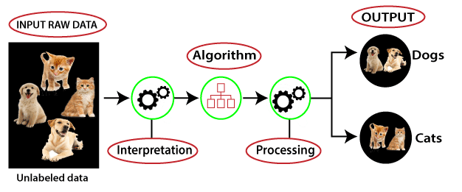

**Types of Unsupervised Learning Algorithm:**

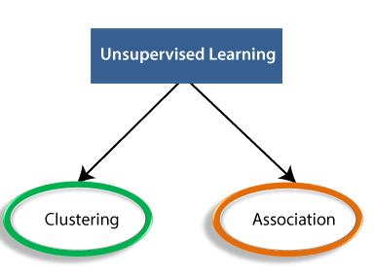

**Clustering:**

* Clustering is a method of grouping the objects into clusters such that objects with most similarities remains into a group and has less or no similarities with the objects of another group.
* Cluster analysis finds the commonalities between the data objects and categorizes them as per the presence and absence of those commonalities.

**Association:**

* An association rule is an unsupervised learning method which is used for finding the relationships between variables in the large database.
* It determines the set of items that occurs together in the dataset.
* Association rule makes marketing strategy more effective. Such as people who buy X item (suppose a bread) are also tend to purchase Y (Butter/Jam) item. A typical example of Association rule is Market Basket Analysis.

**Unsupervised Learning algorithms:**

1. K-means clustering
2. KNN (k-nearest neighbors)
3. Hierarchal clustering
4. Anomaly detection
5. Neural Networks
6. Principle Component Analysis
7. Independent Component Analysis
8. Apriori algorithm
9. Singular value decomposition

**Advantages of Unsupervised Learning**

* Unsupervised learning is used for more complex tasks as compared to supervised learning because, in unsupervised learning, we don't have labeled input data.
* Unsupervised learning is preferable as it is easy to get unlabeled data in comparison to labeled data.

**Disadvantages of Unsupervised Learning**

* Unsupervised learning is intrinsically more difficult than supervised learning as it does not have corresponding output.
* The result of the unsupervised learning algorithm might be less accurate as input data is not labeled, and algorithms do not know the exact output in advance.

**Difference between Supervised and Unsupervised Learning**

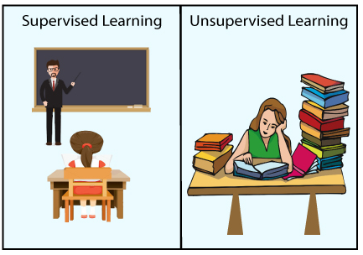

**Supervised learning** needs supervision to train the model, which is similar to as a student learns things in the presence of a teacher. Supervised learning can be used for two types of problems: **Classification and Regression.**

**Unsupervised learning** is another machine learning method in which patterns inferred from the **unlabeled input data**.

The goal of unsupervised learning is to find the structure and patterns from the input data.

Unsupervised learning **does not need any supervision**. Instead, it **finds patterns from the data by its own.**

